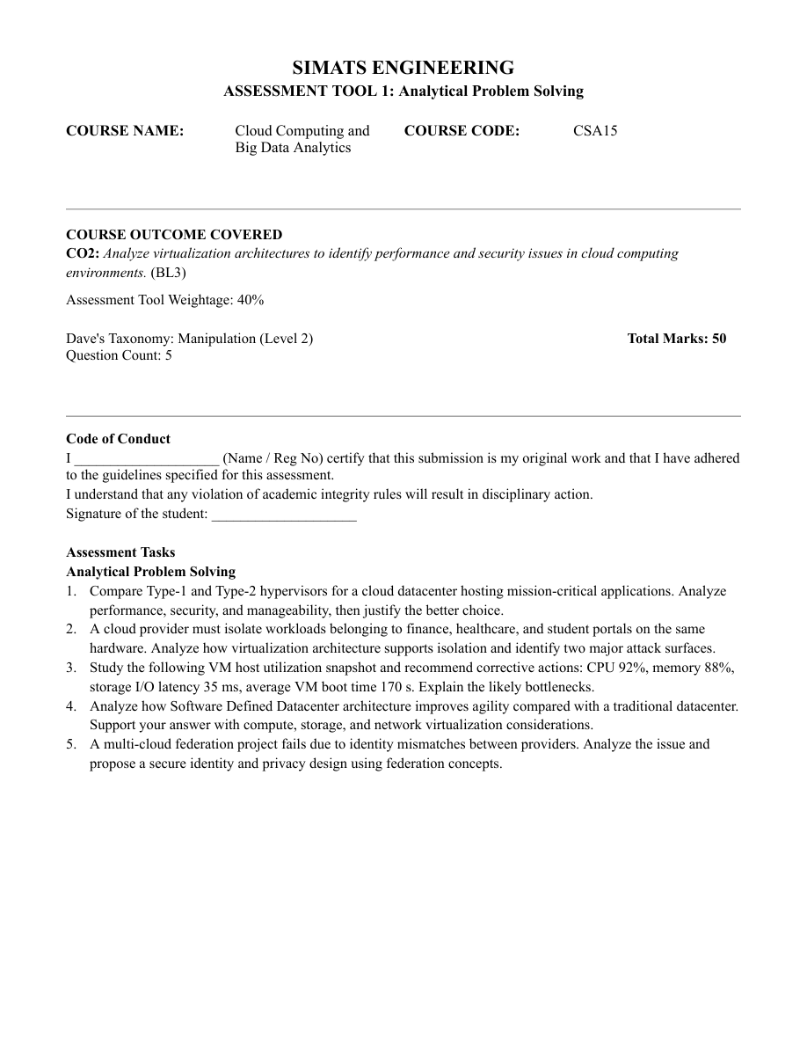

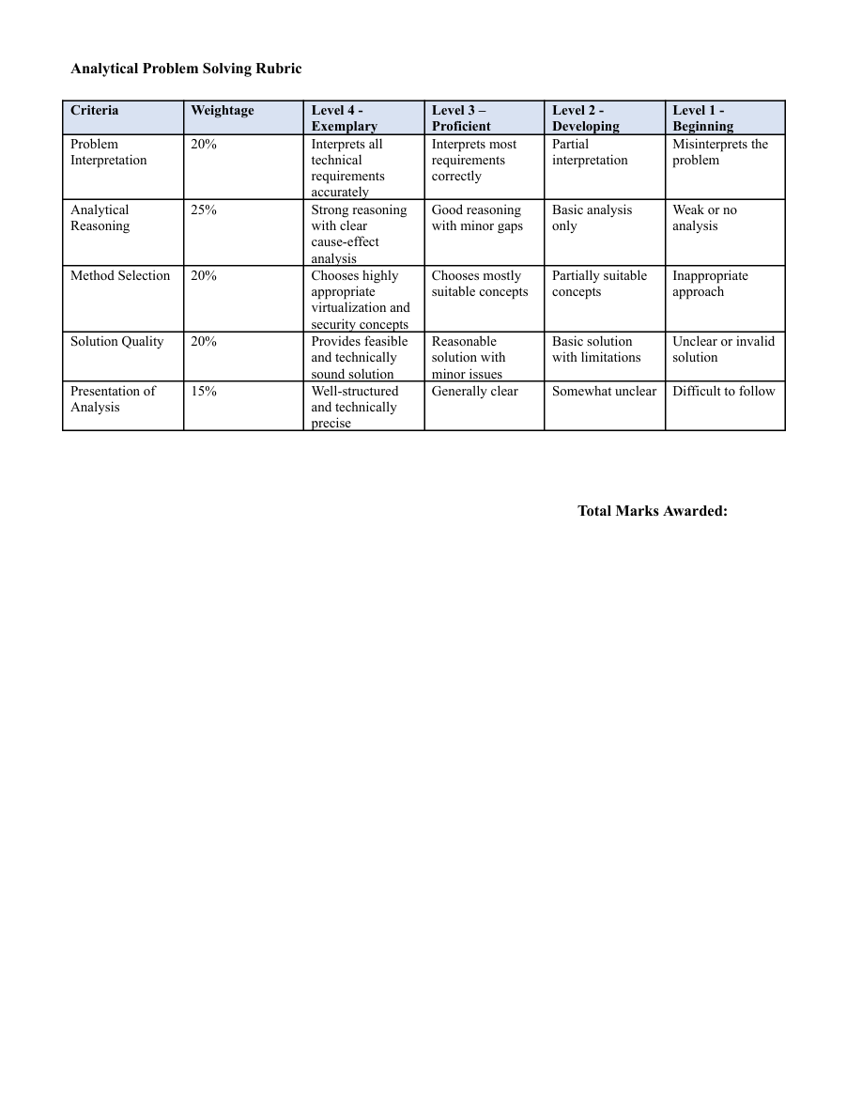

KAVIPRIYA .A
192511201
1: Type-1 vs Type-2 Hypervisors
A hypervisor creates and manages virtual machines (VMs). Type-1 runs directly on physical hardware, while Type-2 runs on top of a host operating system.
- Performance: Type-1 has less overhead and generally provides better performance for mission-critical workloads. Type-2 adds the host OS layer and may have more overhead.
- Security: Type-1 has a smaller software stack and fewer layers to attack. Type-2 depends on the security of both the host OS and hypervisor.
- Manageability: Type-1 platforms are designed for centralized datacenter management, monitoring, and high availability. Type-2 is convenient for desktop testing and development.
- Justification: Choose a Type-1 hypervisor for a cloud datacenter because it offers stronger performance, isolation, and operational control.

2: Workload Isolation and Attack Surfaces
Virtualization allows finance, healthcare, and student-portal workloads to run in separate VMs on the same physical server.
- Isolation: The hypervisor separates VM memory, CPU scheduling, virtual devices, and storage. Virtual networks, access controls, encryption, and separate security policies add protection.
- Attack surface 1 – Hypervisor: A vulnerability may allow a malicious VM to escape isolation and affect the host or other VMs.
- Attack surface 2 – Virtual network/management plane: Misconfigured virtual switches, exposed management interfaces, or stolen administrator credentials may enable unauthorized access.
- Controls: Patch the hypervisor, restrict management access, use MFA and least privilege, segment networks, monitor logs, and encrypt sensitive data.

3: VM HOST UTILIZATION
Given values :
CPU: 92% | Memory: 88% | Storage I/O latency: 35 ms | Average VM boot time: 170 s
Likely bottlenecks :
- CPU at 92%: Very high utilization may cause CPU contention and longer VM response times.
- Memory at 88%: Limited free memory may cause memory pressure, swapping, or ballooning, which can reduce performance.
- Storage latency at 35 ms: This is relatively high for many interactive workloads and may delay reads/writes, VM startup, and application operations.
- Boot time at 170 seconds: Slow startup may result from storage delays, CPU/memory contention, or too many VMs starting simultaneously.
Corrective actions :
- Measure per-VM CPU use; right-size VMs, move workloads to less busy hosts, or add CPU capacity.
- Review memory reservations and overcommitment; reclaim unused allocations or add RAM.
- Check disk queue depth, IOPS, storage-array health, and noisy-neighbour workloads; move critical VMs to faster storage if needed.
- Stagger VM startup, use templates, and monitor performance before and after changes.
Conclusion: CPU and memory are highly utilized, while storage latency is a likely contributor to slow VM boot. Confirm the causes with host and storage monitoring before changing capacity.

4: SOFTWARE-DEFINED DATACENTER
A Software-Defined Datacenter (SDDC) uses software to pool and manage compute, storage, and networking resources. It improves agility compared with a traditional datacenter, where many changes require manual configuration of separate hardware.
Compute virtualization :
- VMs can be created, resized, migrated, and recovered through software-based management.
- Automation and templates speed up provisioning and improve resource utilization.
Storage virtualization :
- Storage from multiple devices can be pooled and presented as logical storage.
- Policies can automate capacity allocation, replication, and performance tiers.
Network virtualization :
- Virtual switches, overlays, and software-defined policies enable rapid network creation and segmentation.
- Workloads can be isolated consistently without repeatedly changing physical network hardware.
Overall benefits :
Centralized orchestration, policy-based automation, faster deployment, scalability, consistent security controls, and easier disaster recovery improve agility. However, SDDC needs skilled administration, strong management-plane security, and monitoring to avoid configuration-wide failures.

5: MULTI-CLOUD IDENTITY FEDERATION
Identity mismatches occur when cloud providers use different identity formats, user identifiers, roles, authentication methods, or trust policies. As a result, users may be denied access or receive excessive privileges.
Secure identity design :
- Use a trusted identity provider (IdP) and federation standards such as SAML 2.0 or OpenID Connect (OIDC), where supported by the providers.
- Map identities and attributes consistently across clouds; use stable unique identifiers and a documented role/claim mapping.
- Apply least privilege and role-based access control. Grant only the permissions required for each workload and review mappings regularly.
- Use multi-factor authentication, short-lived tokens, secure signing keys, TLS, and regular key rotation.
- Validate issuer, audience, signature, expiry, and requested permissions before accepting a federated assertion or token.
Privacy and monitoring :
- Share only the minimum identity attributes needed; avoid sending unnecessary personal or health/financial information between providers.
- Encrypt data in transit and at rest, define retention rules, and log federation events without exposing secrets or excess personal data.
- Revoke sessions and credentials promptly when accounts are disabled; audit cross-cloud access and alert on unusual activity.
Conclusion :
A common federation trust model with consistent identity mapping, strong authentication, least privilege, minimal attribute sharing, and continuous auditing can resolve mismatches while protecting privacy.

